|  |
| --- |
| Photo displaying partial image of two pie charts on a canvas-textured page |
| DIGITAL ASSIGNMENT 6  CSE1007 / JAVA LAB |
| |  |  |  | | --- | --- | --- | | ANISH SHRESTHA | 11/24/21 | 20BCE2893 | |

**DIGITAL ASSIGNMENT -6**

**On Collection:**

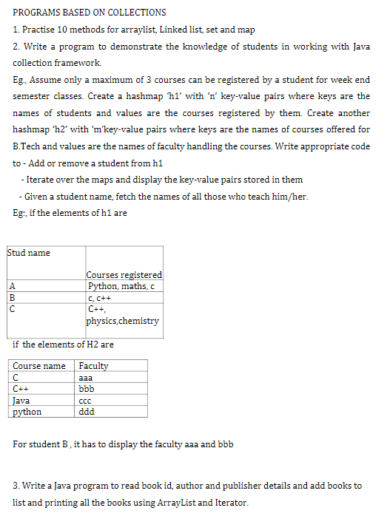

1.

Code:

import java.util.*;

public class MethPrac {

    public static void P_Array() {

        ArrayList<Integer> al = new ArrayList<Integer>();

        for (int i = 10; i <= 18; i++)

            al.add(i);

        System.out.println(al);

        System.out.println("Removing the elemet 3rd & 6th:");

        al.remove(3);

        al.remove(6);

        System.out.println(al);

        // Printing elements one by one

        for (int i = 0; i < al.size(); i++)

            System.out.print(al.get(i) + " ");

        System.out.println("Is ArrayList Empty: " + al.isEmpty());

        System.out.println("using iterator()");

        Iterator<Integer> itr = al.iterator();// getting the Iterator

        while (itr.hasNext()) {// check if iterator has the elements

            System.out.println(itr.next());// printing the element and move to next

        }

    }

    public static void P_linkedlist() {

        LinkedList<Integer> ll = new LinkedList<Integer>();

        for (int i = 1; i <= 5; i++)

            ll.add(i);

        System.out.println(ll);

        ll.remove(3);

        System.out.println(ll);

        for (int i = 0; i < ll.size(); i++)

            System.out.print(ll.get(i) + " ");

    }

    public static void P_hashset() {

        HashSet<String> hs = new HashSet<String>();

        hs.add("Hello ");

        hs.add("VIT");

        hs.add("will");

        hs.add("Open");

        hs.add("soon");

        // Traversing elements

        Iterator<String> itr = hs.iterator();

        while (itr.hasNext()) {

            System.out.println(itr.next());

        }

    }

    public static void P_hashmap() {

        HashMap<Integer, String> hm = new HashMap<Integer, String>();

        System.out.println("Initial list of elements: " + hm);

        hm.put(100, "Anurag");

        hm.put(101, "Beejan");

        hm.put(102, "Anish");

        System.out.println("After invoking put() method ");

        for (Map.Entry<Integer, String> m : hm.entrySet()) {

            System.out.println(m.getKey() + " " + m.getValue());

        }

        hm.putIfAbsent(103, "Jeevan");

        System.out.println("After invoking putIfAbsent() method ");

        for (Map.Entry<Integer, String> m : hm.entrySet()) {

            System.out.println(m.getKey() + " " + m.getValue());

        }

        HashMap<Integer, String> map = new HashMap<Integer, String>();

        map.put(104, "Diwesh");

        map.putAll(hm);

        System.out.println("After invoking putAll() method ");

        for (Map.Entry<Integer, String> m : map.entrySet()) {

            System.out.println(m.getKey() + " " + m.getValue());

        }

    }

    // Main Method

    public static void main(String[] args) {

        System.out.println("Practicing inside arraylist");

        P_Array();

        System.out.println("Practicing inside Linkedlist");

        P_linkedlist();

        System.out.println("Practicing inside Hashset");

        P_hashset();

        System.out.println("Practicing inside Hashmap");

        P_hashmap();

    }

}

Output:

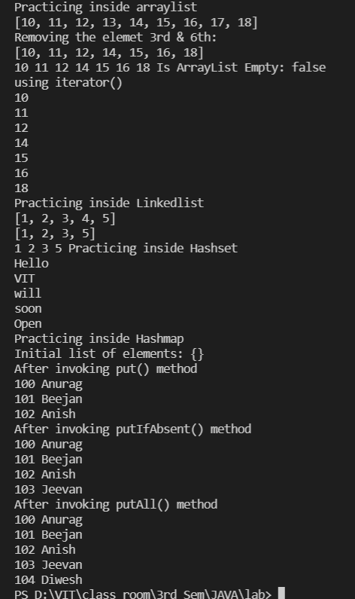

2.

Code:

import java.util.ArrayList;

import java.util.HashMap;

import java.util.List;

import java.util.Map;

import java.util.Scanner;

import java.util.Set;

class Collections {

    static Map<String, List<String>> map1 = new HashMap<String, List<String>>();

    static Map<String, String> map2 = new HashMap<String, String>();

    public void add_in_map1(String key, List<String> values) {

        map1.put(key, values);

        System.out.println(map1);

    }

    public void delete_in_map1(String key) {

        map1.remove(key);

        System.out.println(map1);

    }

    public void findFaculties(String key) {

        if (map1.containsKey(key)) {

            List<String> faculties = new ArrayList<String>();

            List<String> list = map1.get(key);

            Set<String> keys = map2.keySet();

            for (String l : list) {

                for (String k : keys) {

                    if (l.equals(k)) {

                        faculties.add(map2.get(k));

                    }

                }

            }

            System.out.println(faculties);

        } else

            System.out.println("No such student");

    }

    public static void main(String[] args) {

        int c = 1;

        List<String> valSetOne = new ArrayList<String>();

        valSetOne.add("Python");

        valSetOne.add("Maths");

        valSetOne.add("C");

        List<String> valSetTwo = new ArrayList<String>();

        valSetTwo.add("C");

        valSetTwo.add("C++");

        List<String> valSetThree = new ArrayList<String>();

        valSetThree.add("C++");

        valSetThree.add("Physics");

        valSetThree.add("Chemistry");

        map1.put("A", valSetOne);

        map1.put("B", valSetTwo);

        map1.put("C", valSetThree);

        map2.put("Python", "ddd");

        map2.put("Maths", "eee");

        map2.put("C", "aaa");

        map2.put("C++", "bbb");

        map2.put("Physics", "fff");

        map2.put("Chemistry", "ggg");

        map2.put("DBMS", "hhh");

        map2.put("PHP", "iii");

        map2.put("DLD", "jjj");

        map2.put("JAVA", "ccc");

        map2.put("CAO", "kkk");

        System.out.println("Fetching Keys and corresponding [Multiple] Values:\n");

        for (Map.Entry<String, List<String>> entry1 : map1.entrySet()) {

            String key1 = entry1.getKey();

            List<String> values1 = entry1.getValue();

            System.out.println("Key = " + key1);

            System.out.println("Values = " + values1);

        }

        System.out.println("Fetching Keys and corresponding [Single] Values: \n");

        for (Map.Entry<String, String> entry2 : map2.entrySet()) {

            String key2 = entry2.getKey();

            String values2 = entry2.getValue();

            System.out.println("Key = " + key2);

            System.out.println("Values = " + values2);

        }

        while (c == 1) {

            System.out.println("\nEnter choice:\n1. For addition\n2. For Deletion\n3. For Display\n4. Exit\n");

            {

                Scanner sc = new Scanner(System.in);

                int choice = sc.nextInt();

                switch (choice) {

                case 1:

                    Collections c1 = new Collections();

                    List<String> val = new ArrayList<String>();

                    System.out.println("Enter the name of student: ");

                    String s1 = sc.next();

                    System.out.println("Enter the no. of subjects: ");

                    int s2 = sc.nextInt();

                    System.out.println("Enter the name of subjects: ");

                    for (int i = 0; i < s2; i++) {

                        String s3 = sc.next();

                        val.add(s3);

                    }

                    c1.add_in_map1(s1, val);

                    break;

                case 2:

                    Collections c2 = new Collections();

                    System.out.println("Enter the name of student to be deleted: ");

                    String s4 = sc.next();

                    c2.delete_in_map1(s4);

                    break;

                case 3:

                    Collections c3 = new Collections();

                    System.out.println("Enter the name of student: ");

                    String s5 = sc.next();

                    c3.findFaculties(s5);

                    break;

                case 4:

                    c = 0;

                default:

                    System.out.println("Invalid Input");

                }

            }

        }

    }

}

Output:

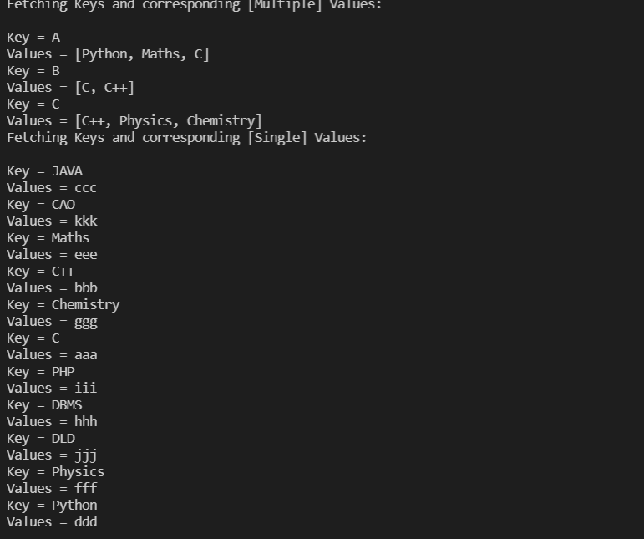

Adding :

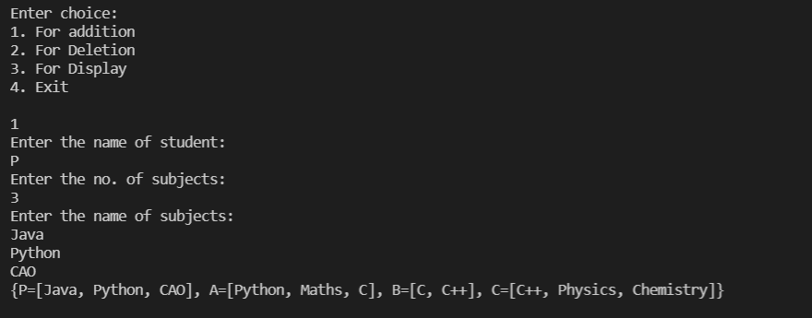

Deleting:

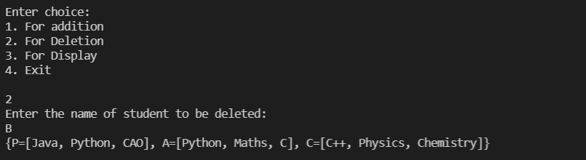

Fetching:

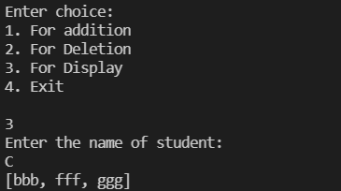

3.

import java.util.ArrayList;

import java.util.Iterator;

import java.util.List;

import java.util.Scanner;

public class Book {

    int book_id;

    String author;

    String publiser;

    public static void main(String[] args) {

        char opt = 'y';

        Scanner sh = new Scanner(System.in);

        List<Book> bookList = new ArrayList<Book>();

        while (opt != 'n') {

            Book b = new Book();

            System.out.println("\nEnter Book ID:");

            b.book_id = Integer.parseInt(sh.nextLine());

            System.out.println("\nEnter Book Author:");

            b.author = sh.nextLine();

            System.out.println("\nEnter Book Publisher:");

            b.publiser = sh.nextLine();

            bookList.add(b);

            System.out.println("\nEnter more details?(y/n)");

            opt = sh.nextLine().charAt(0);

        }

        Iterator<Book> iterator = bookList.iterator();

        sh.close();

        while (iterator.hasNext()) {

            Book element = iterator.next();

            System.out.println("\nBook ID: " + element.book_id);

            System.out.println("\nBook Author: " + element.author);

            System.out.println("\nBook Publisher: " + element.publiser);

        }

    }

}

Output:

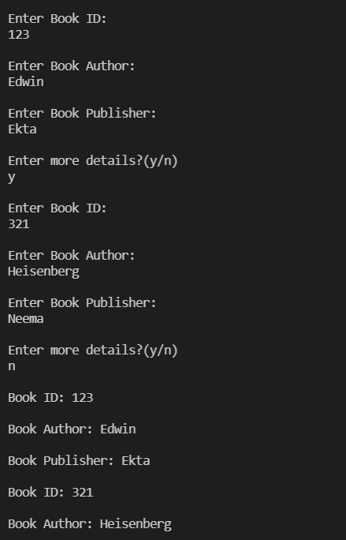

**Make a simple FORM using SERVLET :**

**Code:**

**Index.html**:

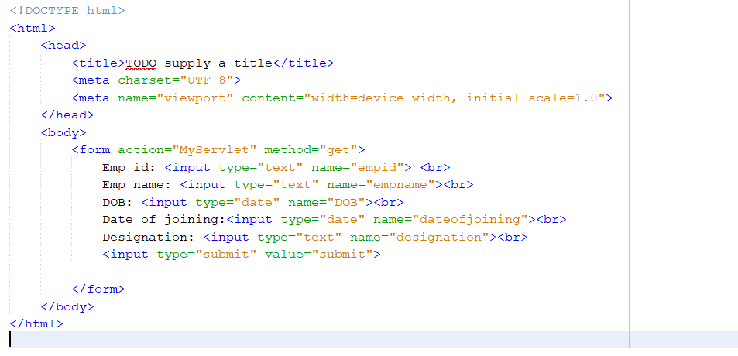

**Servlet.java:**

import java.io.IOException;

import java.io.PrintWriter;

import javax.servlet.ServletException;

import javax.servlet.http.HttpServlet;

import javax.servlet.http.HttpServletRequest;

import javax.servlet.http.HttpServletResponse;

/**

*

* @author ALFA SHERIA

*/

public class MyServlet extends HttpServlet {

@Override

protected void doGet(HttpServletRequest request, HttpServletResponse response)

throws ServletException, IOException {

response.setContentType("text/html");

PrintWriter out = response.getWriter();

String empid =request.getParameter("empid");

String empname =request.getParameter("empname");

String DOB =request.getParameter("DOB");

String date_of_joining =request.getParameter("dateofjoining");

String designation =request.getParameter("designation");

out.print("Employee details:" + empid + empname + DOB + date_of_joining + designation);

}

}

**Servlet mapping:**

<?xml version="1.0" encoding="UTF-8"?>

<web-app version="3.1" xmlns="http://xmlns.jcp.org/xml/ns/javaee" xmlns:xsi="http://www.w3.org/2001/XMLSchema-instance" xsi:schemaLocation="http://xmlns.jcp.org/xml/ns/javaee http://xmlns.jcp.org/xml/ns/javaee/web-app_3_1.xsd">

<servlet>

<servlet-name>MyServlet</servlet-name>

<servlet-class>MyServlet</servlet-class>

</servlet>

<servlet-mapping>

<servlet-name>MyServlet</servlet-name>

<url-pattern>/MyServlet</url-pattern>

</servlet-mapping>

<session-config>

<session-timeout>

30

</session-timeout>

</session-config>

</web-app>

Output:

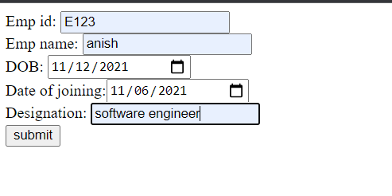

After submission:

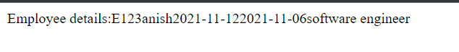

Apache tomcat used for server.